# CS 255 System Design Document Template

This template lays out all the different sections that you need to complete for Project Two. Each section has guidance to prompt your thinking. You will need to continually reference the interview transcript as you work to make sure that you are addressing your client’s needs. There is no required length for the final document. Instead the goal is to complete each section based on what your client’s needs are. Remove this note when you are finished, and replace all bracketed text with the relevant information.

## UML Diagrams

### UML Use Case Diagram

### UML Activity Diagrams

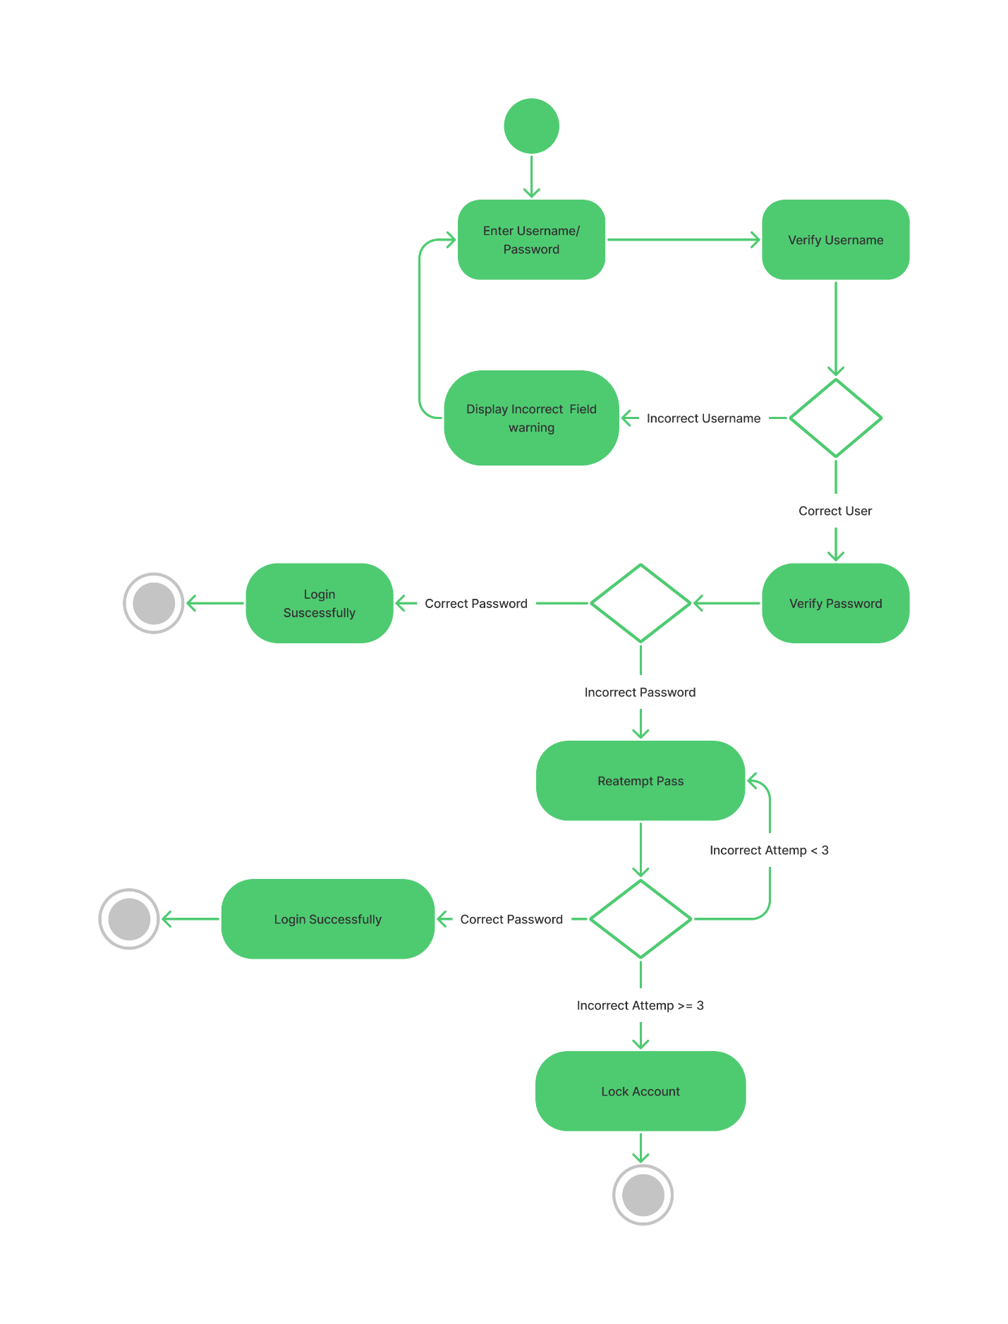

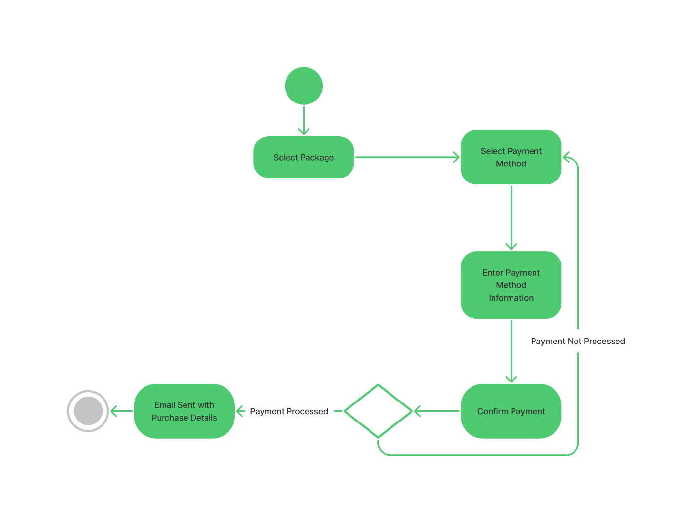

### 

### UML Class Diagram

## Technical Requirements

*DriverPass systems has multiple technical requirements. The interface for DriverPass mainly will be web-based with mobile support, thus we need to ensure the user interface is responsive. We will be storing all the data in a database, and the data can be exported at 1any time for offline review. We will leverage a cloud database such as PostgreSQL which support in depth text search and it’s fast. We will connect the user interface to the database using API endpoints to ensure we can scale to other platforms in the future. We will secure the API endpoints with JWT tokens as the headers and the proper Authorization and Authentication, so our data transfer is safe. A role-based system will be in place to handle the different levels of responsibility efficiently and limiting issues in case an employee account is compromised. The IT Admin will have full control of the system and will be able to perform any action deemed necessary, except working directly with the codebase. To use DriverPass the user can simply access the website through any mobile device or personal computer. DriverPass has the ability to work on any system that support web browsers. The technology stack for DriverPass is React, NextJS and PostgreSQL. Since DriverPass will be hosted on the cloud infrastructure will not be handled by our team.*